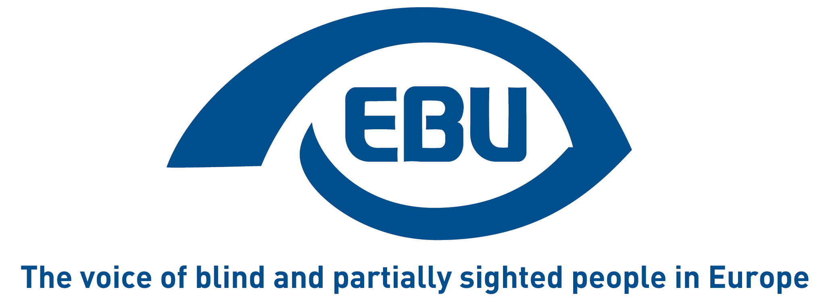

Creative Europe 2021-2027: where are the incentives for audio description and subtitling in MEDIA funding to the film industry?

EBU Statement | 04/07/2022
In our position paper of September 2020, we made the case for the Creative Europe/MEDIA programme to use the leverage of funding to the film industry, to promote inclusion of persons with visual disabilities through audio description and audio subtitling, and we made concrete recommendations to the European Commission.
EBU has been monitoring MEDIA calls for proposals and looking at those most relevant to our demands, to see whether the new Creative Europe Regulation for 2021-2027 is delivering on the hopes it raised for blind and partially sighted film viewers.

Reminder of EBU observations so far
When a political agreement was reached on the new Creative Europe programme in December 2020, we welcomed the commitment to pursue the programme’s objectives “in a way that encourages inclusion, equality, diversity and participation and, where appropriate, through specific incentives that ensure access to culture and creative sectors for groups at risk of social exclusion and marginalisation, namely people with disabilities, and encourage their active participation in those sectors”.
We were also relieved that, despite initial concern that this would not be the case, support measures under the MEDIA strand of Creative Europe continued to explicitly include support for audio description and subtitling.
Eventually, in a statement of June 2021, we observed some positive developments for persons with a visual impairment in the first calls for proposals under the Creative Europe Regulation for 2021-2027, namely that “special attention will be given to applications presenting adequate strategies to ensure (…) inclusion”, among other criteria.

Our remarks one year later
Before looking at the specific MEDIA calls for proposals under Creative Europe 2021-2027, let us first underpin some significant elements of the description of the two most relevant MEDIA clusters on the Creative Europe portal.

Noteworthy and missing elements of the MEDIA cluster description

“Audience” cluster:
Among the ways to support audience development, “ensuring access” is mentioned, but unfortunately, when it comes to the means through which to achieve access to content, only support to subtitling is mentioned and not audio description and audio subtitling.

“Policy support” cluster:
The portal indicates a particular focus under this cluster inter alia on “encouraging inclusion, equality, diversity and participation”. This echoes the commitment in the Regulation on how Creative Europe objectives should be pursued. The portal’s description further lists some actions to achieve this objective, including:
- Advice on the implementation of the Audio-visual Media Services Directive. We are curious to learn how concretely this action will materialize in the Creative Europe framework, and to what extent attention will be paid to Article 7. In our position paper we pointed out that Article 7 of the revised Directive requires media service providers in Europe to make their services continuously and progressively more accessible to persons with disabilities, including through audio description and audio subtitling.
- Advocacy campaigns involving relevant pan-European organisations and highlighting the contribution of the audio-visual ecosystem to the consolidation of European values. Regrettably, the focus of such campaigns appears to be only on diversity and gender balance.

Content of MEDIA calls for proposals under new Regulation
The calls we have analysed are:
- “Networks of European Festivals”; “MEDIA 360°”; Films on the Move”; “European Film Distribution”; Innovative Tools and Business Models” – published in February 2022
- “European VOD Networks and Operators” – published in March
- “Networks of European Cinemas” – published in April
- “European Co-development – published first in February and then again in May
Our remarks concern three distinct sections of the calls:

Background:
It is a good thing that this largely standard section of the calls systematically recalls that Creative Europe objectives should be pursued in a way (inter alia) that encourages inclusion, namely through incentives to ensure access to culture for people with disabilities.

Objectives - Themes and priorities - Activities that can be funded - Expected impact:
In all of the calls but one – “Networks of European Festivals” – applicants are expected to present adequate strategies to ensure, inter alia, inclusion. However, disability, let alone visual impairment, is not mentioned in any of the calls. And encouraging audio description, despite it being listed among the MEDIA support measures, is mentioned in only two of the calls: “Films on the Move” and “European Film Distribution”. There is no mention of audio subtitling in any of the calls.
The silence on measures for inclusion is particularly sad in the “MEDIA 360°” call, precisely because of its wide scope across the board of the value chain.

Weight in award criteria:
Where present – i.e. in all calls except “European Film Distribution” and “Networks of European Cinemas” – “Presenting adequate strategies to ensure gender balance, inclusion, diversity and representativeness”, as a criterion for relevance of applications, counts for 5% of the total points in the award criteria. By comparison, similar calls under the previous period of the Creative Europe programme did not mention inclusion at all in the award criteria.
However, the single and specific weight of inclusion, namely of persons with disabilities (let alone blind and partially sighted people) is unknown and, as far as we can tell, could very well be null, especially where there is no mention of promoting audio description and (audio) subtitling in the objectives, priorities or activities that can be funded.

Reminder of our recommendations
- Audio description and audio subtitling should be included among the selection and award criteria based on which proposals eligible for MEDIA funding are assessed.
- At least 25% of films that receive MEDIA funding should have an audio description and audio subtitling.

Conclusions
From where we stand, we have no possibility to see whether in practice MEDIA, through its funding, is in effect promoting audio description and audio subtitling. We would be happy to get some feedback on this from the competent service at the European Commission.
What we can say, judging by the MEDIA institutional communication and calls for proposals, is that there is no visible emphasis on making films accessible for visually impaired people. This is probably because the Creative Europe regulation does not include a legal obligation for the programme’s executive agency to have measurable goals as far as promoting inclusion is concerned.
We are aware that Creative Europe also funds cooperation projects to promote the development of audiences with disabilities and the involvement of artists with disabilities in the culture sector. However, we believe that promoting the inclusion of persons with disabilities should be mainstreamed in all of the programme’s funding.
The European Union acceded to the United Nations Convention on the Rights of Persons with Disabilities (CRPD) and it is responsible for its implementation to the extent of its competences. This of course includes EU funding. Article 30, paragraph 1 of the CRPD defines the right of persons with disabilities to take part on an equal basis with others in cultural life. Among other, it obliges State Parties to “take all appropriate measures to ensure that persons with disabilities (…) enjoy access to (…) films (…) in accessible formats”.
We ask the Commission to use the opportunity of the mid-term review of the Creative Europe regulation 2021-2027, to consider introducing some benchmarking in the regulation on how MEDIA funding is used to promote inclusion, and in particular accessible films for people with visual impairment.
The European Blind Union (EBU) EBU is one of the six regional bodies of the World Blind Union, and it promotes the interests of blind and partially sighted people in Europe. Our 41 national member organisations in Europe include 25 European Union member states (all the EU except Latvia and Malta).

European Blind Union
6 rue Gager Gabillot - 75015 Paris
+33 1 88 61 06 60 | ebu@euroblind.org | www.euroblind.org

Contact: Antoine Fobe, Head of Campaigning
ebucampaigning@euroblind.org | +33 1 88 61 06 64

