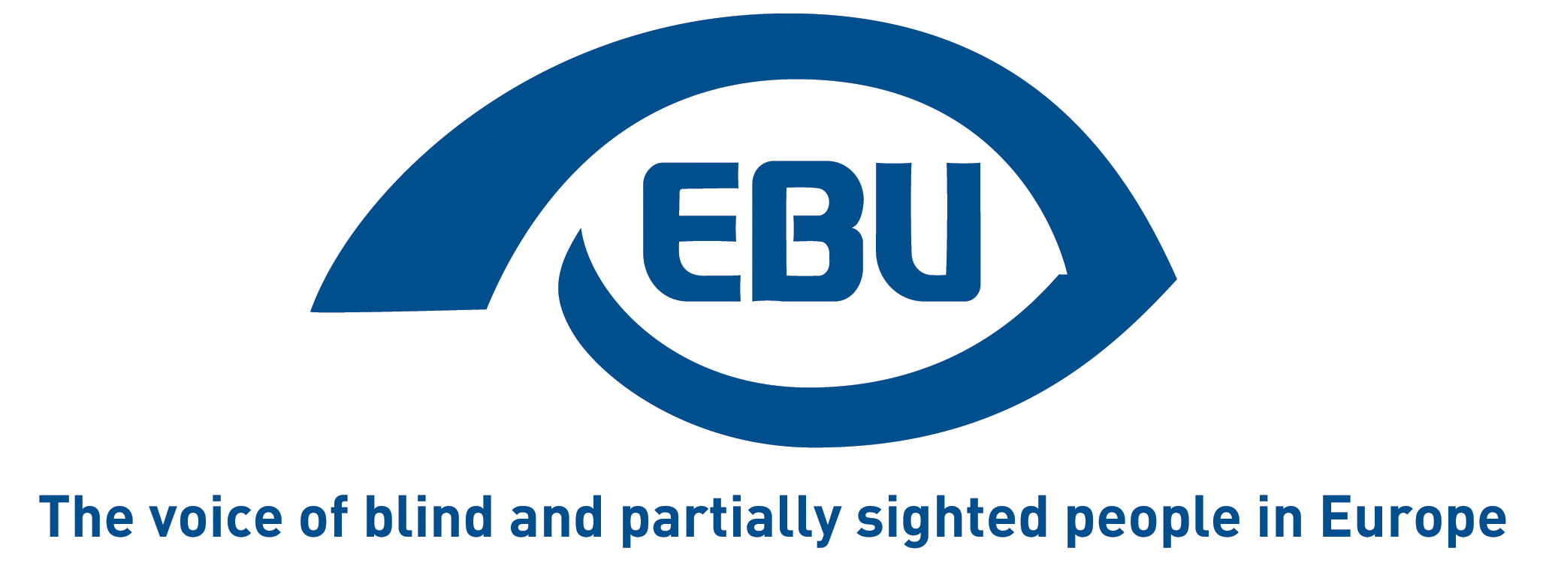

Making the 'new normal' inclusive for all.

Some key lessons to be learned from the crisis, the perspective of blind and partially sighted people.
EBU Position Paper September 2020

Background
Undoubtedly, the Corona virus has been changing our lives dramatically. In particular the lockdown measures that were implemented in many countries have had a massive impact on almost all areas of life. While this is true for all of us, this unprecedented situation presented, and in some cases continues to present, even more challenges for the estimated 30 million blind and partially sighted people in Europe. In this document, the European Blind Union (EBU), attempts to draw some key lessons learned from the crisis. We do so in the hope that those lessons learned will greatly help societies at large to be more inclusive for visually impaired people moving forward; whether in a situation of a major crisis or at “normal” times.
We build on ongoing feedback we gathered from our members across Europe throughout the lockdown phase, but also on a series of specific interviews we conducted after most countries started lifting those measures. Thus, this document constitutes a continuum of EBU’s work carried out during the lockdown when, amongst other things, we compiled feedback from our members on a dedicated resource page. Through our advocacy and communications, we also supported work undertaken by our allies at the European and global level.
Our key messages in this document are targeted at a wide range of stakeholders, from policy-makers to the general public. This is due to the nature of the crisis in which all citizens became actors in combatting the spread of the virus.
Of course, beyond the general key observations that we make, blind and partially sighted people may have had an individual experience very different from this “big picture”. Further research, especially at national or local level, would be needed to analyse more in depth the experience in key areas such as education, employment, access to services, etc. The document describes both the challenges for visually impaired people that were exacerbated by the crisis, and a number of new challenges that occurred as a result. It concludes with some observations on the role that blindness organisations played throughout these unusual times.
We would like to warmly thank all the people whose input enabled us to draft this paper and in particular Francesca Sbianchi (Italy), Katarina Bigovic (Montenegro), Lasse Jalonen (Finland), Marc Powell (United Kingdom), Irma Jokštyte (Lithuania), Kevin Kelly (Ireland), Peter Brass (Germany) and an anonymous person (Sweden) who granted us their time for in-depth interviews.

Accessibility is key
Especially in times of crisis, accessibility, in all its dimensions, reveals its full value. During the lockdown digital accessibility in particular became an indispensable feature of life in so many areas. And this showed both potential but also massive challenges for blind and partially sighted people.
For example, working from home, based on information and communication technology, became a positive experience for many people and certainly opened-up new perspectives for the time after the crisis. At the same time it also had the potential of excluding visually impaired workers in cases where the technology in use was not accessible to them. That negative experience was often exacerbated by the difficulty in seeking assistance that was not available at the time it would have been needed (compared with an office setting where a colleague could have provided support). Very similar observations could be made in the area of education, where inaccessible platforms, learning material and the unavailability of personalised assistance also created cases of exclusion. As remote education is expected to play an increasing role, even beyond times of crisis, the lessons learned should inform future initiatives in that area.
With a huge amount of rapidly changing and sometimes contradictory information being released by authorities every day, access to information became even more important than in “normal” times. And while generally speaking blind and partially sighted people could access most of the information (using a mix of different channels), accessible and alternative formats such as Braille or large print were often made available only after the blindness organisations had alerted their authorities to provide such formats. In other cases, the blindness movement even had to produce alternative formats for their members.
Access to a number of other services and activities also turned out to be challenging during lockdown and after. For example, public transport, which is the essential system for their mobility for many people, ran only at much reduced frequency or even stopped altogether. In addition, both the means of transportation and the stations had undergone significant changes (e.g. a certain number of seats had to be left empty, entering and exiting stations was regulated differently etc.). Most of these changes were only explained to travelers visually, meaning that blind and partially sighted people could even not know about them. Similarly, though in a different area of activity, all the changes that were made in shops such as supermarkets were only labelled in a visual manner, so that blind and partially sighted clients could not be aware of them unless staff made themselves available to explain the changes verbally.

The importance of using all our senses
While most of the previous points pre-existed and were exacerbated by the Corona crisis, some aspects are also specific to the nature of the COVID-19 pandemic. Most prominently, the concept of ‘social distancing’. This poses real challenges to many visually impaired people. While even the terminology of social distancing was hardly known to the general public prior to Corona, it became one of the strongly recommended strategies to fight the spread of the virus, and will continue to apply for quite some time. The main challenge for blind and many partially sighted people is to assess the distance of people surrounding them. This is especially true when there is no conversation taking place. Typically this scenario can be observed in lines and queues. In that situation, it is important that people identify themselves verbally, for example when the line is moving, so that a blind or partially sighted person knows when to move.
Another key element to fighting the spread of the virus is face masks. Wearing them makes it more difficult for partially sighted people to recognise faces, and to look at people’s faces during a conversation. We therefore recommend the use of transparent masks and ask the industry and public authorities to ensure they are available at reasonable prices compared to other types of face masks. For blind persons, masks make it harder to communicate with other people, for example when asking for or receiving help, as the voice is lowered by the mask. So it is more challenging to catch people’s attention.
Moreover, a very different challenge presents itself: which is to understand where in practice the wearing of masks is compulsory. In many places, a differentiated approach to that question has been taken. But the signage is often visual, and therefore, again, not accessible to blind and many partially sighted people.
The sense of touching has also been affected by the Corona virus. Now that it is recommended not to touch items unnecessarily, using that sense becomes viewed negatively by a great number of members of society. But touching is an essential part of independent living for many blind people, as it replaces, at least in some ways, their sight. It allows, for example, to distinguish different products or helps to recognise front doors of houses, just to name a few practical examples. So not being allowed to use that sense, often means being more dependent on asking others for help.
Social distancing, wearing masks and a minimal use of touch, are three effective tools to help combat the Corona virus. So the challenges described here are by no means to question their importance and effectiveness! The aim is to raise awareness about those challenges in wider society, and to help all of us to react appropriately in the spirit of accommodating different needs. At the end of the day, common sense is as important a sense as seeing, hearing or touching!

The Blindness movement as actor for change
Like every individual and organisation at all levels, the Blindness movement had to adapt to the new reality of COVID-19 within an extremely short timeframe. It did so, first and foremost to continue to serve its members, who were often in greater need of that support in that unprecedented situation. In many places, blindness organisations set-up a hotline to give guidance and advice to their members, and to relay the latest information regarding COVID-19. Furthermore, a number of organisations offered services to their individual members helping them with daily life activities such as shopping or administrative tasks. This essential support was put in place where individuals could not access other assistance services that they used normally.
At the political level, blindness organisations played a critical role in advocating for an inclusive and accessible COVID-19 response by political authorities. In most cases, this was done in connection with the wider Disability movement. While the results of those advocacy efforts obviously vary from one country to another, it is fair to say that without the strong voice of the Blindness movement, the emergency responses would have been much less inclusive of our community. Very tangible achievements such as the permission to be accompanied by someone outside the family (a guide) or the provision of fully accessible digital forms, would not have been possible without the intervention of the Blindness community.
The successes of the Disability movement, including blindness organisations, were facilitated where effective mechanisms of their participation in decision-making did exist/or were put in place at the beginning of the Corona crisis. This is an important lesson learned and should be turned into a systematic practice in the future.
No doubt, the focus of our advocacy efforts is now shifting away from a purely “emergency angle” to a much more comprehensive agenda; namely to ensure that blind and partially sighted people and their representative organisations are fully included in the recovery plans, so that they receive a fair level of protection during the expected economic down-turn, and are not further left behind when the economy gets back on its feet.
ENDS

About EBU
The European Blind Union (EBU) – Interest Representative Register number 42378755934-87 – is a non-governmental, non-profit making European organisation founded in 1984. It is one of the six regional bodies of the World Blind Union, and it promotes the interests of blind and partially sighted people in Europe. It currently operates within a network of 41 national members including organisations from 27 European Union member states, candidate countries and other countries in geographical Europe.
European Blind Union
6 rue Gager-Gabillot - 75015 Paris
ebu@euroblind.org | www.euroblind.org

Contact: Gary MAY, Information Officer
ebuinfocom@euroblind.org | +33 1 81 61 06 63

