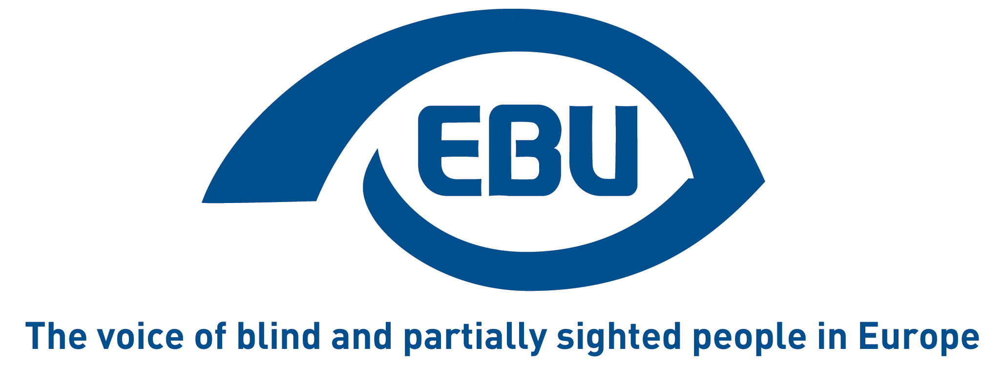

About using Braille for operating buttons of lifts

EBU Statement | May 2023

Context
Working group 7 of Technical Committee 10 of the European Committee for Standardisation (CEN/TC 10 WG 7) is currently reviewing the EU standard for “Accessibility to lifts for persons, including persons with disability” (EN 81-70).
In that context, the accessibility of buttons/devices for the operation of lifts is being discussed, and the question arises whether Braille should be provided in addition to tactile letters/numbers.

We have been informed about the following arguments put forward within CEN/TC 10 WG 7, to exclude using Braille:
- Some blind people are not familiar with Braille.
- Braille does not come in a single international language and requires translation.
- Embossed/tactile characters suffice, at least for numbers.
- Braille would require too much space considering the size and quantity of operating buttons.

Against that background, the European Blind Union (EBU) finds it necessary to make a statement clarifying our position specifically on that matter and not excluding other considerations.

Responding to the arguments
That some blind people are not familiar with Braille is true. Less educated blind people may not have had the chance to become familiarised with Braille. Besides, there is indeed a tendency nowadays to think that the new information technologies undermine the importance of Braille. This is to be deplored, also because it has not been proven that blind people tend to rely less Braille. We refer here to our statement of February 2022 on “Access to Reading and Using Braille” in which we explain why Braille remains essential, namely as a matter of education and access to the more qualified jobs for blind people. It should be emphasised that those who are familiar with Braille will always prefer Braille labelling over any other form of presentation. This is in analogy to someone having the choice between their mother-tongue or reading the same text in a foreign language. The obligation to provide Braille in the built environment, and specifically in lifts, should therefore not be undermined, as it would affect blind people’s motivation to learn Braille as a tool for more qualitative social inclusion.
We also consider that the argument that Braille requires translation is also not valid to exclude using Braille, for the following reasons. Braille is not a proper ‘language’, but rather a conventional, universal writing system for visually impaired people. Indeed, there are differences in Braille between countries—albeit not for Arabic numerals, identical for all languages. But this is not specific to Braille, i.e., written messages in or outside a lift that are for non-visually impaired users will exclude many international travellers, for instance, if they are only in the local language. So, where only one language is provided for text information to non-visually impaired users (be it the local language or a widely used international language), the same would apply to Braille. Besides, a number of important operating buttons, such as ‘Stop’ and ‘Alarm’ can easily be recognised by all, in Braille as in text, as very common English words used worldwide
As for the argument that in any case embossed marking is sufficient at least for Arabic numerals, we strongly disagree, because not all blind people actually know them. Many will have learned numbers in their youth directly in Braille format, without ever seeing an Arabic numeral.
Lastly, the argument that using Braille requires too much space is invalid, because, on the legal side, it is an obligation, under the UN Convention on the Rights of Persons with Disabilities (Article 9, paragraph 2 d), for EU Member States and the EU legislator within its area of competence, to “provide in buildings and other facilities open to the public signage in Braille and in easy to read and understand forms”. And, on the practical side, a number of other buttons are only marks which, in the lack of space, could have only embossed marking if easily recognisable through touch.

Recommendations
Consequently, if accessibility to visually impaired people of operating buttons for lifts is to be ensured—and here we don’t consider contrast issues for partially sighted people—push buttons of any type and function (e.g., floor numbers, Stop, Alarm) in the lift, but also call buttons at ground level and on each floor, should have both embossed marking AND Braille, unless a recognisable symbol is used, such as directional arrows for ‘Up’ or ‘Down’ and convergent or divergent arrows for ‘Close doors’ or ‘Open doors’, in which case embossed marking would suffice in the lack of space for Braille labelling.
The Braille marking should be next and as close as possible to the button, so as to minimise confusion which button the Braille label refers to, yet at a minimal distance from that button and any other button, so as to avoid unintentional activation. For the same reason, it should not be on the button itself, especially where the button is touch-sensitive or responds to light pressure.

Further reading
See our position paper of February 2019: “Accessibility of Lifts: Why the European standard EN 81-70:2018 fails to meet the legal requirements”.

About EBU
The European Blind Union (EBU) – Interest Representative Register number 42378755934-87 – is a non-governmental, non-profit making European organisation founded in 1984. It is one of the six regional bodies of the World Blind Union, and it promotes the interests of blind and partially sighted people in Europe. It currently operates within a network of 41 national members including organisations from 25 European Union member states, candidate countries and other countries in geographical Europe.
European Blind Union
6 rue Gager Gabillot - 75015 Paris
+33 1 88 61 06 60 | ebu@euroblind.org | www.euroblind.org

Contact: Antoine Fobe, Head of Advocacy and Campaigning
ebucampaigning@euroblind.org | +33 1 88 61 06 64

